Project Design Phase-II

Data Flow Diagram & User Stories

# Project Details:

|  |  |
| --- | --- |
| Date | 20 June 2025 |
| Team ID | LTVIP2025TMID55215 |
| Project Name | ResolveNow: Your Platform for Online Complaints |
| Maximum Marks | 4 Marks |

# Data Flow Diagrams:

A Data Flow Diagram (DFD) is a graphical representation of the flow of information within a system. For ResolveNow, it shows how complaints are registered, processed, and resolved.  
  
Example (Simplified):

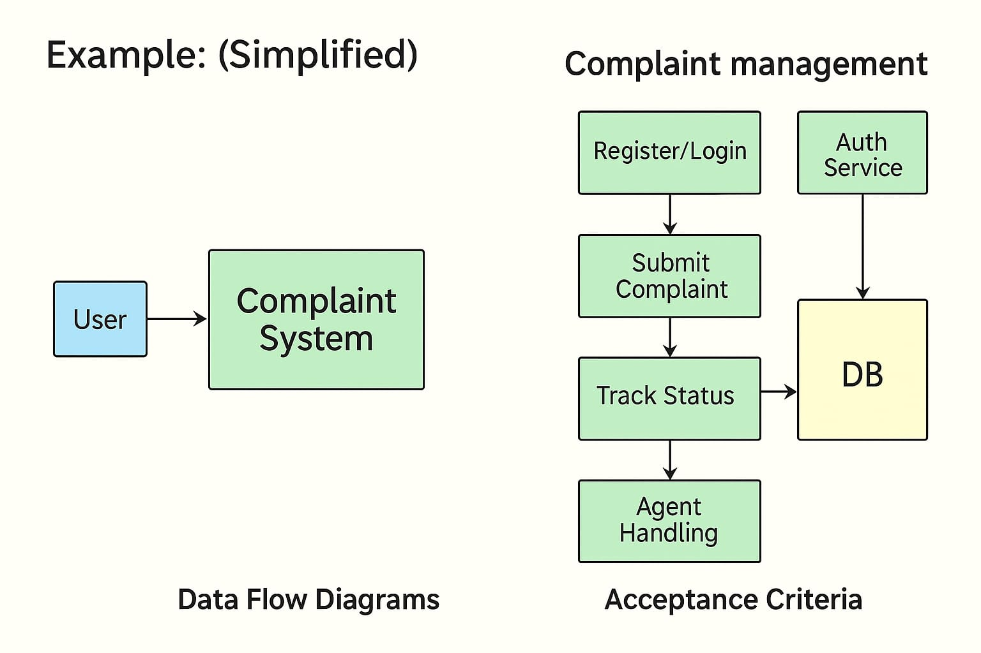  
  
1. User sends request (register, login, submit complaint, track complaint)  
2. System stores/updates data in MongoDB (user profile, complaint records, resolution updates)  
3. System responds with complaint status, notifications, and resolution details  
4. Admin and Agents interact with the system to update complaint status, provide resolutions, and communicate with users.

# User Stories

|  |  |  |  |  |  |  |
| --- | --- | --- | --- | --- | --- | --- |
| **User Type** | **Functional Requirement (Epic)** | **User Story #** | **User Story / Task** | **Acceptance Criteria** | **Priority** | **Release** |
| Customer | Registration | USN-1 | As a customer, I can register with email and password. | I can access my dashboard. | High | Sprint-1 |
| Customer | Login | USN-2 | As a customer, I can log in using email and password. | I can access my dashboard. | High | Sprint-1 |
| Customer | Complaint Submission | USN-3 | As a customer, I can submit a complaint with details and attachments. | The complaint is recorded and visible in my dashboard. | High | Sprint-1 |
| Customer | Complaint Tracking | USN-4 | As a customer, I can track my complaint status in real-time. | Status updates are visible in the dashboard. | High | Sprint-2 |
| Customer | Communication | USN-5 | As a customer, I can chat with the assigned agent. | Messages are exchanged successfully. | High | Sprint-2 |
| Customer | Feedback | USN-6 | As a customer, I can give feedback after resolution. | Feedback is recorded and linked to the complaint. | Medium | Sprint-3 |
| Agent | Complaint Handling | USN-7 | As an agent, I can view assigned complaints and update their status. | Complaint status updates are reflected in user dashboard. | High | Sprint-2 |
| Agent | Communication | USN-8 | As an agent, I can chat with the customer for clarification. | Messages are delivered and stored. | High | Sprint-2 |
| Admin | Admin Dashboard | USN-9 | As an admin, I can manage all users and complaints. | Admin panel updates backend & reflects in UI. | High | Sprint-3 |
| Admin | User Management | USN-10 | As an admin, I can approve/suspend users and assign complaints to agents. | User and complaint status updated in system. | Medium | Sprint-4 |